SOFTWARE PROCESS MODELS  Ruchita Shah | Chapter 2

Objectives
The objective of this chapter is to introduce concept of software process. Software process is a set of activities carried out throughout software development. When you will read this chapter you will :
- Understand concept of software process;
- Learn about various linear process models;
- Gain knowledge about advantages and disadvantages of various process models.

Introduction
Every software engineering organization have a described set of framework activities (as discussed in chapter 1) as part of their software development strategy. These set of prescribed framework activities are known as process models. Every software project have different framework activity. Thus for different software project different process model is applied based on nature of project, methods, available tools, controls and deliverables required. These process models are also known as Software Development Life Cycle (SDLC). All process model are categorized in 2 category: (1) linear and (2) evolutionary. In this chapter we will examine linear software process models.
The waterfall Model
Also known as Classical Life Cycle Model or Linear Sequential Model because of its sequential nature. Many a times requirements of a software project is very well understood and developer can work in a linear fashion from communication through deployment then waterfall model is applicable.
In "The Waterfall" approach, the whole process of software development is divided into separate phases. The outcome of one phase acts as the input for the next phase sequentially. Thus each phase must be completed before the next phase can begin and there is no overlapping in the phases.
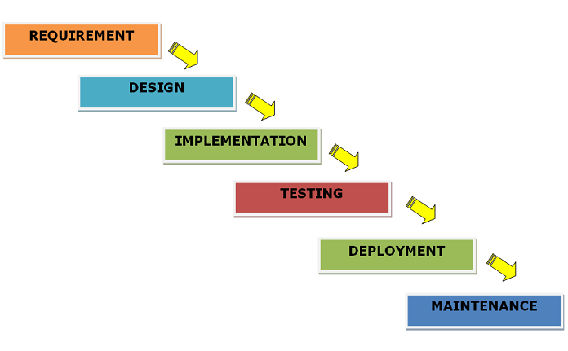
Fig. – The Waterfall Model
Requirement Gathering − All possible requirements of the software to be developed are collected and documented in a requirement specification document.
System Design − The requirement specifications from first phase are analyzed and converted into system design. This system design helps in specifying hardware and system requirements and helps in defining the overall system architecture.
Implementation − With inputs from the system design, the system is first developed in small programs called units, which are integrated in the next phase. Each unit is developed and tested for its functionality, which is referred to as Unit Testing.
Testing − All the units developed in the implementation phase are integrated into a system after testing of each unit. Post integration the entire system is tested for any faults and failures.
Deployment of system − Once the functional and non-functional testing is done; the product is deployed in the customer environment or released into the market.
Maintenance − There are some issues which come up in the client environment. To fix those issues, patches are released. Also to enhance the product, some better versions are released. Maintenance is done to deliver these changes in the customer environment.
All these phases are cascaded to each other in which progress is seen as flowing steadily downwards (like a waterfall) through the phases. Every software developed is different and requires a suitable SDLC approach to be followed based on the internal and external factors. Waterfall model will be most appropriate where:
- Requirements are very well documented, clear and fixed
- Product definition is stable
- Technology is understood and is not dynamic
- Ample resources with required expertise are available to support the product
- The project is simple and short
Advantages :
Waterfall model allows for departmentalize and controlled development. A schedule can be set with deadlines for each stage of development and a product can proceed through the development process model phases one by one. Major advantages of the Waterfall Model are:
- It is quite simple and easy to understand and use
- Easy to manage due to the rigidity of the model. Each phase has specific deliverables and a review process
- Phases are clearly defined and completed one at a time
- Works well for smaller projects where requirements are very well understood
- Process and results are well documented

Disadvantages
Waterfall model do not allow revision if development is in the next stage. For e.g. if an application is in the testing stage, it is very difficult to go back and change something that was not implemented properly or a change in design is required. The major disadvantages are:
- No working software is produced until late during the life cycle. So developer and customer both need to keep patience
- It is not a good model for complex and object-oriented projects
- Not suitable for long and ongoing projects
- Not suitable for the projects where requirements are changing
- System integration is done at the very end, which doesn't allow identifying any technological or business bottleneck or challenges early.
The Incremental Model
Incremental model combines the elements of waterfall model in an iterative manner. In the incremental model of software engineering, waterfall model is repeatedly applied in each increment. The incremental model applies linear sequences in a required pattern as calendar time passes. Each linear sequence produces an increment in the work. Thus it delivers a series of releases called increments which provide progressively more functionality for the client as each increment is delivered.

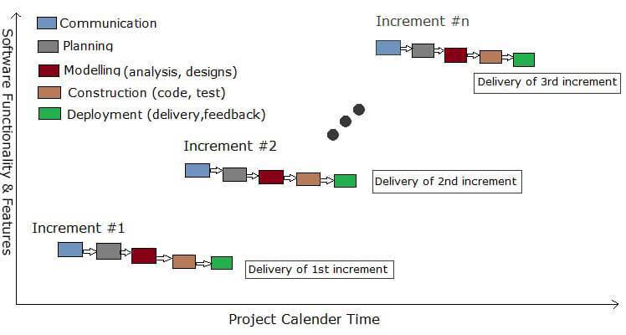
Fig. – The Incremental Model

Incremental approach is iterative in nature. Model focuses on delivery of an operational product with each increment.
Advantages
When incremental model is used, first increment is often a core product in which basic requiremnts are fulfilled. Many supplementary features are delivered in next increments. Incremental model is useful when staff is anavailable for a complete implementation within a deadline. Further advantages of the model are :
- Developer can develop prioritized requirements first
- Initial product having basic requirements are delivered early
- Customers gets important functionality early which can be evaluated early
- Each release is a product increment, so that the customer will have a working product at hand all the time
- Customer can provide feedback to each product increment, which helps to plan next increment
- Changes in requirements can be easily accommodated
Disadvantages
To implement incremental model, the software problem must be divided into well defined increments at the planning stage. The disadvantages of the Incremental model are:
- Requires effective planning of increments
- Requires efficient design to ensure inclusion of the required functionality and provision for changes later
- Requires early definition of a complete and fully functional system to allow the definition of increments
- Well-defined module interfaces are required, as some are developed long before others are developed

The RAD model

The Rapid Application Developemnt (RAD) model is acually a high speed adaptation of waterfall model. Development cycle in RAD model is short. A software project can be implemented using this model if the project can be broken down into small modules wherein each module can be assigned independently to separate teams. These modules can finally be combined to form the final product.
Development of each module involves the various basic steps as in waterfall model i.e communication, planning, business modelling, data modelling, process modelling, construction and testing and turnover. Another striking feature of this model is a short time span i.e the time frame for delivery is generally 60-90 days. RAD model distributes the analysis, design, build and test phases into a series of short, iterative development cycles.

Business Modeling - The business model identifies flow of information and the distribution of information between various business channels. A complete business analysis is performed to find the vital information for business, how it can be obtained, how and when is the information processed and what are the factors driving successful flow of information.
Data Modeling - The information gathered in the Business Modeling phase is reviewed and analyzed to form sets of data objects vital for the business. The attributes of all data sets is identified and defined. The relation between these data objects are established and defined in detail in relevance to the business model.
Process Modeling - The data object sets defined in the Data Modeling phase are converted to establish the business information flow needed to achieve specific business objectives as per the business model. The process model for any changes or enhancements to the data object sets is defined in this phase. Process descriptions for adding, deleting, retrieving or modifying a data object are given.

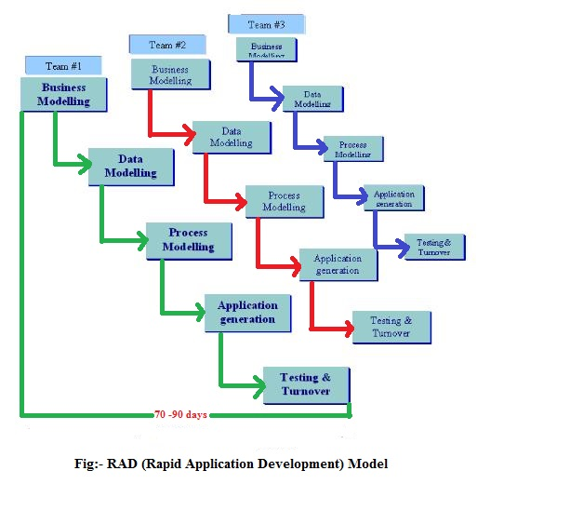
Construction - The modules are built and coding is done by using automation tools to convert process and data models into actual prototypes. Emphasis is given on use of pre-existing software components.

Testing and Turnover - The overall testing time is reduced in the RAD model as each module is independently tested during every iteration. However, the data flow and the interfaces between all the components need to be thoroughly tested with complete test coverage. Since most of the programming components have already been tested, it reduces the risk of any major issues.
After turnover, customer feedback is taken to identify if more iteartion are required or not. If a businness application is highly modular in nature and if its major functions are to be implemented in a short time span, than RAD model is applicable to it. Each major function can be developed by a separate RAD team and then integrated to form a whole product.
Advantages
- Use of reusable components and automatic code generation tools helps to reduce the cycle time of the project
- Continuous feedback from the customer is available from the beginning of the project which helps in building high quality product
- Project development progress can be measured through the various stages
- It is easier to accommodate changing requirements due to the short iteration time spans
Disadvantages
- This model requires sufficient developers to create necessary number of teams
- Customer involvement is required throughout the life cycle
- If the product is not highly modular in nature, RAD model can not be applied
- The use of powerful and efficient tools requires highly skilled professionals
- RAD model is not appropriate for project with high technical risk

Activity 1
Identify which model will be more appropriate for following definitions.
- The software organization has developed similar project in past. _______________
- Customer has defined a very strict deadline for the project.___________________
- The project can be compartmentalize in 3 different compartments and there is sufficient staff. ______________
- Customer is able to specify all his requirements from the beginning._____________
- Customer has defined stringent deadline but all functionalities are not required that time. ________________
- Reusable components and project construction tools are to be used. ____________

Activity 2
For all the three process models, populate following table.
Process Model | Strength | Weakness | Types of project
Waterfall Model

Incremental Model

Rapid Application Development (RAD) model

Summary
A process model is a general process specification which is useful in many projects. To bring order and structure to software development, process models have been applied. All of prescriptive process models perform almost same set of framework activities: communication, planning, modelling, construction and deployment.
Waterfall model has linear sequential advancement but many projects do not possess linear flow. When similar project has been devloped in the past or when requirements are well defined and stable, waterfall model is most appropriate model.
Incremental model produces software in increments. This model is applicable for project with stringent deadline. RAD model is appicable to large and highly modular projects.
Answers to Activity

Activity 1
Identify which model will be more appropriate for following definitions.
- The software organization has developed similar project in past. _The Waterfall Model_
- Customer has defined a very strict deadline for the project. The Incremental Model_
- The project can be compartmentalize in 3 different compartments and there is sufficient staff. _The Rapid Application Development (RAD) model_
- Customer is able to specify all his requirements from the beginning._ The Waterfall Model_
- Customer has defined stringent deadline but all functionalities are not required that time. __ The Incremental Model_
- Reusable components and project construction tools are to be used. _ The Rapid Application Development (RAD) model

Activity 2
For all the three process models, populate following table.
Process Model | Strength | Weakness | Types of project
Waterfall Model | - Simple  - Easy to execute  - Best for small & similar projects  - Well documented | - Requirements once established do not change  - Project completion time is long  - No scope for user feedback  - Chnages in-between the project are not allowed  - Requires patients of developer & customer  - Not good for technical break through projects | - Small projects  - Well understood problems  - Simiar project successfully implemented in past  - Automation of existing manual system
Incremental Model | - Quick delivery at regular interval  - Alllows for customer feedback  - Changes can be accomodated | - Proper planning before each increment is required  - Frequent changes may adversely affect system and its architecture | - For businesses where strict time schedule is followed  - When requirements are changing
Rapid Application Development (RAD) model | - Very short delivery cycle  - Use of reusable components and tools  - Changes can be easily accomodated | - Large number of developers for many teams are rquired  - Highly skilled developers for automation tools  - Full involvement of customer  - Not suitable for high technical risk projects | - For problems which are highly modular and less time schedule  - When reusable components are used

